Form 03 (REGISTRATION)
NEW DIVER ASSESSMENT

PART A

Objective
A new diver is defined as any person who fulfils the requirements of section 8.2, 8.3, 8.4, 8.5 or 8.6 of The University of Western Australia Scientific Diving Procedures Manual 2010, but has not previously dived for the school (and/or any authorised school divers) for the purposes of occupational diving operations.
Before departure, all new divers that will be assisting in or conducting diving operations must complete an assessment dive with the UWA Diving and Boating Safety Officer (DBSO). Exceptions are:
  - If the DBSO has authorised a dive team leader (as per section 6.2.5 of The University of Western Australia Scientific Diving Procedures Manual 2010) to conduct the orientation of a new diver; or
  - If the DBSO has authorised the orientation dive to be conducted at the start of a field trip by either the DBSO themselves or a DBSO approved delegate.

New divers must show an understanding and proficiency in both pre-dive and in water skills. Pre-dive assessments must evaluate a new diver’s proficiency and familiarity with the following skills and knowledge:
  - New divers must understand and agree to follow the Scientific Diving Procedures Manual, have an understanding of the procedures to be followed in the event of an accident and know where to find them for reference in an emergency.
  - New divers must be familiar with the DCIEM decompression diving tables and be able to use them to plan diving operations. Refer to Scientific Diving Procedures Manual; Section 14.5; Appendix DV5; ‘DCIEM Sport Diving Tables’.
  - New divers must show proficiency in the setup and operation of the SCUBA equipment being used;
  - New divers must understand basic underwater signals and signs as detailed in Section 3 of this document.
  - New divers must understand buddy responsibilities such as contact and lost buddy procedures as described in several sections of the Scientific Diving Procedures Manual.
The above pre-dive assessments must be documented by having the new diver read through and understand each skill. Once proficiency has been reached by the new diver they must sign a copy of each document to signify their understanding of and proficiency in each skill (refer to Section 2). The documents will be kept on record by the DBSO.
In water skills must evaluate a new diver’s proficiency with the following skills:
- Entries and exit from small craft/beach
- Surface swim 25 metres alternating between snorkel and scuba
- Correct ascents and descents using BCD (check rates and techniques)
- Buoyancy control by fin pivot and by hovering motionless
- Regulator removal and recovery
- Mask clearing
- Scuba equipment removal and recovery
- Alternate air source use - octopus rig (2nd reg.)
- Simulated emergency swimming ascent (horizontal)
- Simulated surface rescue tow of conscious and simulated unconscious diver
- Record new divers air consumption.
In water skill assessments will be documented by the DBSO or DBSO approved delegate by completing the in water skills check list as per Section 2. This will be kept on record by the DBSO.

In-Water New Diver Skill Assessment

Assessor:
New Diver:
Date:
Location:
Wind (0-5, 5-10, 10-15, 15+ knots):
Sea (Calm, Slight, Rough): Swell (0-1, 1-2, 2+):
Visibility (0-5, 5-10, 10-20, 20+ m):

Skill | Demonstrated Skill | Comments
1. Entry and Exit
2. Surface Swim
3. Correct Ascent and Descent
4. Buoyancy Control
5. Regulator removal and Recovery
6. Mask Clearing
7. Scuba equipment removal and recovery
8. Alternate air source use
9. Simulated horizontal emergency swim
10. Simulated rescue tows

11. New Divers Air Consumption

Air In | Air Out | Time In | Time Out | Depth (m) | Bottom time (min) | Rep Group

Hand signals to be used to communicate while diving

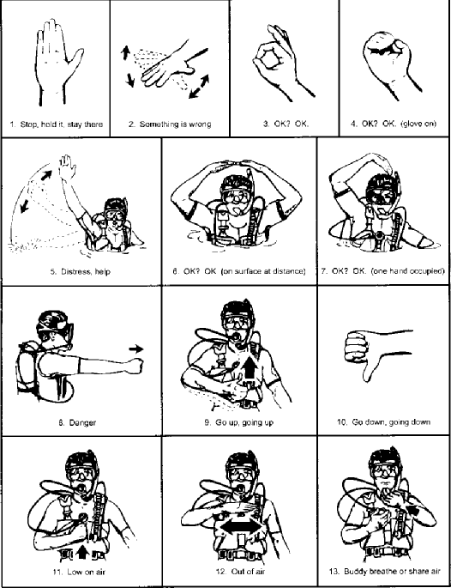

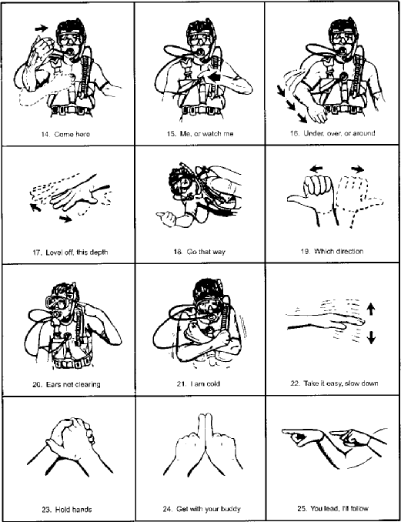
- - - - - - - - - - - - - - - - - - - - - - - - - - - - - - - - - - - - - - - - - - - - - - - - - - - - - - - - - - - - - - - - - - - - - - - - - - - - - -

PART ‘A’ DECLARATION:
This document must be signed by the new diver once they fully understand and are proficient in each skill set out in PART A. It must also be endorsed by an approved assessor.

New Diver Signature: | Print Diver Name: | Date:
Assessor Signature: | Assessor Print Name: | Date:

New Diver Assessment | Published: March 2024 | Version 1.2
Authorised by University Diving and Boating Safety Working Group | Review: March 2026 | Page 4 of 11
This document is uncontrolled when printed. The current version is available on the Safety and Health website

PART B

Application of DCIEM Tables

Tables A, B, C and D: DCIEM Sport Diving Tables
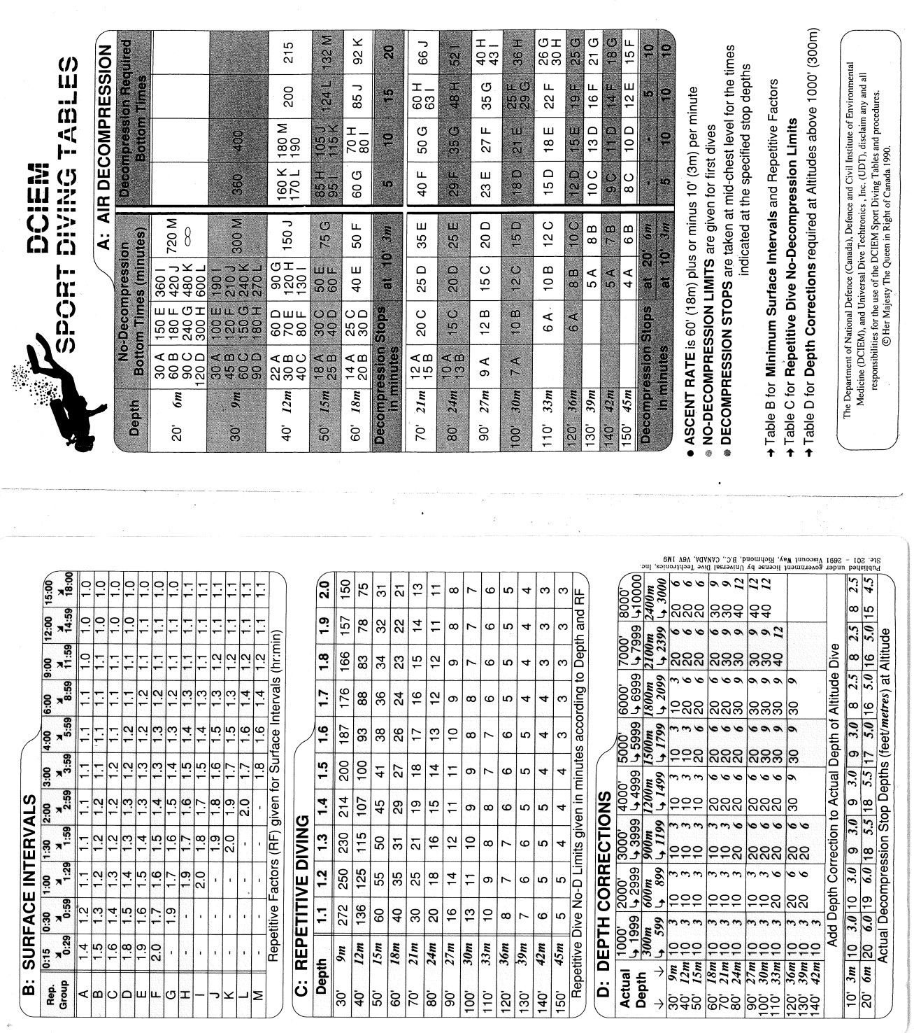

Table A gives the No-Decompression Limits (No-D limits) for first dives and the decompression stop times needed for dives which exceed the No-D limits.
A No-D limit is the maximum bottom time that you may spend on a dive without having to conduct a decompression stop before resurfacing. Personnel diving with UWA must stay within the No-D limits.
To find the No-D limit for a given depth, enter Table A from the depth column and follow the row of numbers across to the bold, vertical lines. The largest number to the left of the bold, vertical lines is the maximum No- D limit (expressed in minutes) for a first dive.
Beside each number is a Repetitive Group (RG) letter. RG’s are dive exposure guides. To find your RG, use the exact or next greater bottom time value for the first dive. If no group letter appears beside your bottom time, allow 24 hours to elapse before your next dive.
The proper ascent rate for using the DCIEM Sports Diving Tables is 18 metres plus or minus 3 metres per minute.
The section to the right of the bold, vertical lines is used only for decompression dives*. The required decompression stops are given in minutes at the bottom of each column.
E.g. First dive to 21m for 40 minutes No-D Limit is 35 minutes
Decompression stop is 5 minutes at 3m RG for 40 minutes at 21m is ‘F’
*Note decompression diving is not allowed by the University

Table B: Surface Intervals
A surface interval is the time elapsed between surfacing from a dive and beginning the actual descent on the following dive. In Table B, surface intervals are expressed in hours and/or minutes.
Enter Table B using the group letter from your last dive. Match your group letter with your surface interval. The amount of residual nitrogen remaining in your body is indicated in the form of a Repetitive Factor (RF), the highest RF being 2.0.
As your surface interval increases, your RF decreases. When your RF reaches 1.0, your nitrogen level will be back to normal. Any dive conducted while your RF is greater than 1.0 is classified as a repetitive dive.
If your RF has diminished to 1.0, use Table A to plan your next dive.
If your RF is greater than 1.0, use No-D limits in Table C to plan your next dive.
Before conducting a repetitive dive, allow enough surface interval time to elapse for a RF to appear in Table B.
If you must dive before a RF appears, use the following emergency guidelines for short surface intervals:
- For dives to be the SAME DEPTH: add the actual bottom times together and use the Effective (total) Bottom Times to determine your RG in Table A;
- For Dives to DIFFERENT DEPTHS: use the “Step system’ (explained in the Multi-level diving section) to find the equivalent time for your first dive RG at the second depth. Add the actual bottom time at the second depth and use the Effective (total) Bottom Time to find your new RG.

Flying after diving
After a single No-D dive, allow your RF to drop to 1.0 before flying.
After a repetitive dive or a decompression dive, allow a surface interval of at least 24 hours before flying.

Table C: Repetitive Dive No-D Limits

The No-D Limits for repetitive dives are given in Table C. On a repetitive dive, the No-D limit is reduced because of residual nitrogen remaining from the preceding dive. To find the No-D Limit for a repetitive dive, match the depth with your RF taken from Table B.

Example: Depth of 12m with RF of 1.5
No-D Limit of 100 minutes.

If you stay within the No-D limits and do not conduct another repetitive dive, no calculations are necessary. After 18 hours, you can begin your next dive using the No-D Limits in Table A.
If you plan to conduct another repetitive dive (3rd dive), you will need to find your Effective Bottom Time (EBT) for dive #2. To find your EBT, multiply the actual bottom time by your RF.

The RG for dive #2 is found in Table A according to the depth and EBT. Example: Depth of Repetitive Dive is 12m
RF is 1.5 No-D Limit is 100 minutes. Actual bottom time is 60 minutes EBT = 60 min x 1.5 = 90 minutes
RG = ‘G’
Whenever the actual bottom time on a repetitive dive exceeds the No-D limit given in Table C, a decompression stop is required. Decompression stops for repetitive dives are found in Table A according to the depth and EBT (On a decompression repetitive dive, the EBT may result in a figure that is less than the Table A No-D limit although the actual bottom time exceeds the table C No-D Limit. If this occurs, conduct a 5 minute stop at a depth of 3m).
Match the actual bottom time with your RF. Example: Actual bottom time is 65 minutes
RF = 1.5
EBT for 65 minutes
Is 60 minutes = 90 minutes
Plus 5 minutes = 8 minutes EBT = 98 minutes

Minimum Surface Intervals for No-D Dives
Table C and Table B can be used together to find the minimum surface interval needed to conduct a No-D repetitive dive. Use Table C to find the RF that corresponds with your actual bottom time. Use Table B to match this RF with the RG letter from your last dive. The minimum surface interval is given at the top of the matching column in Table B.
Example: First Dive 24m for 25 minutes.
RG = E
Repetitive dive 18m for 31 minutes

In Table C, a RF of 1.3 is required at the beginning of the repetitive dive
In Table B Group E diver acquires RF of 1.3 after a surface interval of 2 hours.

Adjustments for Multiple Repetitive Dives

Whenever you conduct three or more dives in a series, the RG for each repetitive dive must be higher than that of the preceding dive. DCIEM recommends a limit of 3 dives in a series.
If your RG is lower than or the same as that of the preceding dive and the surface interval before your next dive is less than 6 hours, make the following adjustment:
- Add one letter to the RG from the preceding dive and apply the adjusted RG to your current repetitive dive.
Example: First dive RG = ‘D’, second dive RG = ‘B’
-less than 6 hours before 3rd dive-
Raise the second dive RG letter to ‘E’ (First dive RG ‘D’ + 1 letter)

No adjustment is needed if the surface interval before the next dive is 6 hours or longer.

If 3 or more dives a day are conducted on 3 consecutive days, allow for a 24 hour surface interval after the 3rd day.

Multi Level Dives
A multi-level dive is a dive during which bottom time is spent at two or more depths before surfacing.
During a multi-level dive, the normal decompression process that occurs during a direct ascent to the surface is interrupted by the partial ascents resulting from the steps in the multi-level profile.
The following procedures are to be used with the DCIEM Sport Diving Tables for No-D multi-level dives conducted in either warm or cold weather:
- Each multi-level dive is to be a NO-DECOMPRESSION DIVE; If a No-D Limit is exceeded, abort the dive and proceed to the decompression stop(s) specified in Table A.
- Conduct the DEEPEST PART of the dive FIRST. Ascend at least 6m between steps in the dive. At depths greater than 30m, ascend at least 9m.
- FINISH the dive in SHALLOW water in a depth range between 3m and 6m for at least 5 minutes of actual bottom time. Include the time spent at this depth in your bottom time.
- After each dive, allow for a surface interval of at least 1 hour.

First dive Multi-level Procedures

 |  | 6 m | Step 3
15 m | Step 2 |  | E = 150 min  + 20 min (ABT)  = 170 min (EBT) = F
Step 1 | C = 30 min  + 20 min (ABT)  = 50 min (EBT) = E

ABT : Actual Bottom Time EBT : Effective bottom Time In Table A, find your RG for Step 1 according to the depth and ABT.
1st Dive
F
27 m
15 min = C
Example: Step 1 is at 27m for 15 minutes (No-D limit is 20 minutes) RG for step 1 is ‘C’

Use Table A to find the equivalent time for RG ‘C’ at Step 2. Add your ABT to the equivalent time for RG ‘C’. The total time is your EBT at Step 2. Your EBT must not exceed the No-D Limit given for Step 2.
Step 2 is at 15m for 20 minutes (No-D limit is 75 minutes) Equivalent time for ‘C’ = 30 minutes
ABT = 20 minutes
EBT = 50 minutes RG for Step 2 is ‘E’

Find the equivalent time for RG at ‘E’ at step 3. Add your ABT to the equivalent time. Your EBT must not exceed the No-D limit for step 3.
Step 3 is at 6m for 20 minutes (No-D limit is infinity) Equivalent time for ‘E’ = 150 minutes
ABT = 20 minutes
EBT = 170 minutes RG for Step 3 is ‘F’

Repetitive Dive Multi-Level Procedures
On a repetitive dive, your actual bottom time at Step 1 must not exceed the No-D limit given in Table C.

Example: RF is 1.3
Step 1 is at 21m, (No-D limit in Table C is 21 minutes) ABT = 20 minutes
EBT = 20min x 1.3 = 26 minutes RG for step 1 is ‘E’
The RG for Step 1 is taken from Table A according to the depth and EBT. Your RG for Step 1 must be equal to or greater than the RG from you preceding dive.
Example: If the RG from the preceding dive was ‘F’ and the RG for Step 1 is ‘E’, raise ‘E’ to ‘F’ before step 2.
Because you must ascend at least 6m between steps, step 2 should be conducted at a depth of 15m or less.

Your EBT at Step 2 must not exceed the No-D Limit given in Table A.

Step 2 is 15m for 10mins, (No-D Limit is 75 minutes) Equivalent time for RG ‘F’ = 60 minutes
Actual Bottom Time = 10 minutes Effective Bottom Time = 70 minutes RG for Step 2 is ‘G’

Before surfacing, spend at least 5 minutes at a depth between 3m and 6m. Regardless of whether you conduct this as the final step in the dive or as a safety stop, the time you spend at this depth must be included in your EBT.

Step 3 is at 6m for 10 minutes (No-D Limit is ‘infinity) Equivalent time for RG ‘G’ = 240 minutes
Actual Bottom Time = 10 minutes Effective Bottom Time = 250 minutes RG for Step 3 is ‘H’

Multi-Level Procedures Summary
- First dive: your ABT at Step 1 must not exceed the No-D Limit in Table A. Your EBT (or total bottom time) at each subsequent step must not exceed the No-D limit given for that step.
- Repetitive dive: your ABT at Step 1 must not exceed the No-D Limit given in Table C. The RG taken from Step 1 must be equal to or greater than the RG from your preceding dive. Your effective bottom time at each subsequent step must not exceed the No-D Limit given in Table A.
- Finish the dive in shallow water (between 3m and 6m) and allow for a surface interval of at least 1 hour after each dive.

Table D: Depth Corrections (for altitude divers)
Table D is used to convert the actual depth at high altitude to an effective depth that corresponds with Table A and Table C depth figures intended for use at sea level. Table D provides the depth corrections and actual decompression stop depths needed to conduct dives at altitudes between 300m and 3,000m above sea level.

Depth corrections are necessary when diving at altitude because the reduced atmospheric pressure at the surface of the dive site makes the altitude dive equivalent to a much deeper dive at sea level. When you arrive from a lower altitude, your body will already have some residual nitrogen as a result of the decrease in atmospheric pressure.
Use the following procedures only after you have acclimatised at the altitude of the dive site for 12 hours:
    - Establish the altitude of the dive site and the actual depth of the altitude dive;
    - Convert the actual depth to effective depth by adding the depth correction given in Table D;
    - Apply the effective depth and the actual bottom time to Table A to determine the decompression requirements for the altitude dive (for repetitive dives, refer to the No-D limits given in Table C);
    - If the altitude dive is a decompression dive, conduct the decompression stop at the actual stop depth specified in Table D; and
    - Decompress at the actual stop depth for the decompression stop time given in Table A.

Example: Altitude = 1,800m Actual depth = 18m
Bottom Time = 35 minutes Depth Correction = 6m Effective depth = 24m
Dec. stop = 10 minutes at 3m (from Table A) Actual Dec. stop depth is 2.5m (from Table D)

At altitudes above 1,500m, reduce your ascent rate to 15m/min.

If you must dive before 12 hours have elapsed, begin by using the next greater depth than the actual depth. Using the example given above, you would begin the depth correction procedure as if the actual depth were 21 meters. The effective depth would be 27m (21m + 6m). The decompression required at actual stop depths would be 5 minutes at 5m and 10 minutes at 2.5m.

- - - - - - - - - - - - - - - - - - - - - - - - - - - - - - - - - - - - - - - - - - - - - - - - - - - - - - - - - - - - - - - - - - - - - - - - - - - - - -

PART ‘B’ DECLARATION:
This part must be signed by the new diver once they fully understand the use of Tables A, B, C and D: DCIEM Sport Diving Tables as described in PART B. It must also be endorsed by an approved assessor.

New Diver Signature: | Print Diver Name: | Date:
Assessor Signature: | Assessor Print Name: | Date:

