DRAFT – WORK IN PROGRESS GUIDE FOR APPROVER GROUPS
Global Engagement Office – International Partner Agreements Database (GEO-IPAD)

Background
- Terra Dotta is a web-based software solution provider that can automate and streamline processes for Agreement proposals, approvals and contract renewals for all international agreements (articulation, MoU’s, mobility, joint degree, research, etc).

- The Terra Dotta Agreements module (GEO-IPAD) is expected to link to existing UWA systems and will be the repository of all activity/engagement related to partnerships across UWA.

GEO-IPAD website
- This UWA URL link will be available for public viewing (including all UWA staff) to provide a simple overview of UWA’s partnerships. An example is shown below.
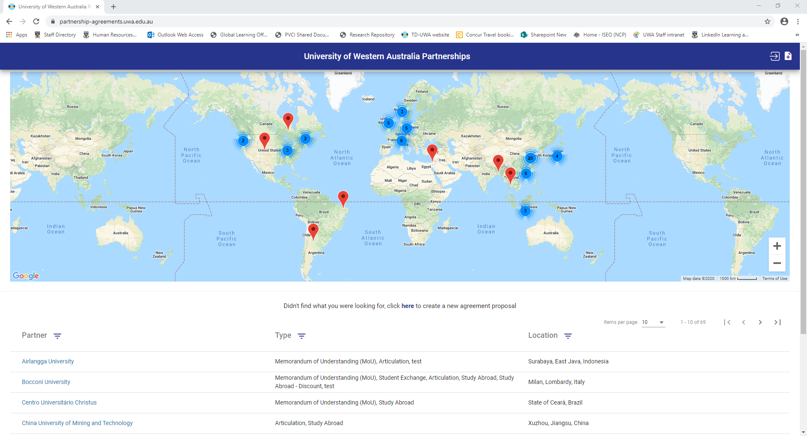

- The information viewed on this page can be filtered by partner, type of agreement and/or location or by simply zooming in/out of the map view.

- UWA users can submit new agreement proposals via the UWA log in (top right hand corner) or by clicking create new proposal.
Process for establishing new agreements

PHASE 1 – Proposer submit new (DRAFT) proposal to Agreements Administrators
UWA users will be able to log in with their Pheme credentials and submit new agreement proposals. Depending on agreement type selected, UWA users will be asked to submit relevant supporting documentation (Feasibility Study, Checklist etc). A User Guide for Proposers will be available to assist UWA users on how to complete the forms.

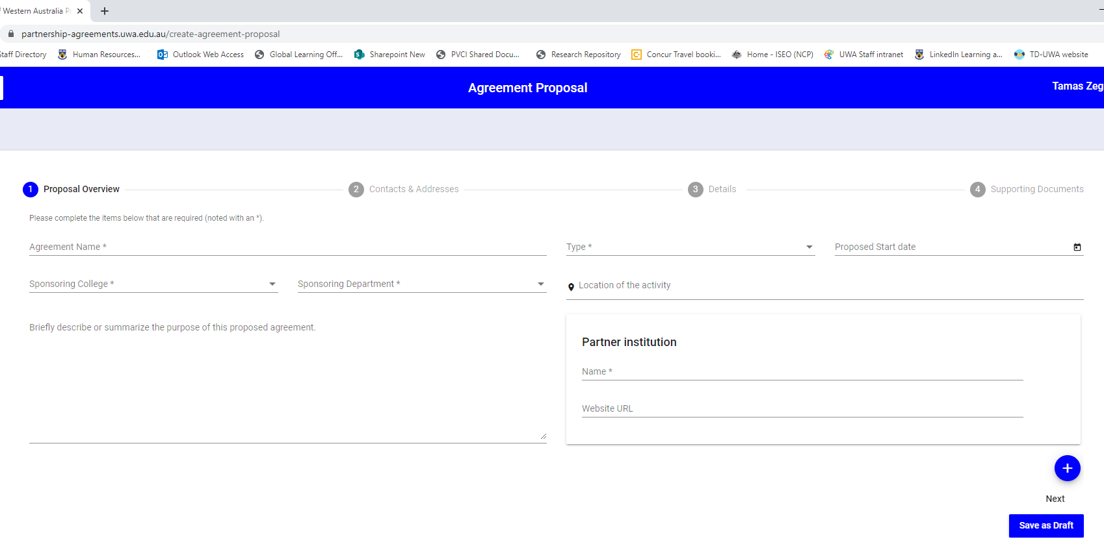
Screen shot below of new agreement proposal created via GEO-IPAD:

PHASE 2 – Agreement Admin review proposal and submit (FINAL) proposal for approval
A notification will be sent to Agreement Admin (GEO staff) for each proposal that is submitted from the GEO-IPAD website. The Agreement Admin will review each proposal to ensure mandatory fields have been completed, all relevant documentations are attached (feasibility, checklist etc) and any other preliminary checks/approvals (Risk and Legal/ Finance) are in place. Agreement Admin will then submit proposal to begin the agreement approval process.
Note: Proposal will be routed to relevant approver based on the workflow for different agreement types and the sponsoring Faculty/School. (ie Faculty sponsor of proposal will be routed through Faculty Approval group and different supporting documentation can be uploaded depending on agreement type)

PHASE 3 – Agreement Approval workflow
When a final proposal is submitted final proposal for approval, an automated email is sent to the relevant approver groups based on agreement type workflows. A typical workflow will include approval from GLO, ADI, HoS, CAB once preliminary checks (School endorsement, Finance/Risk and Legal approval – where required etc) have been obtained.

Example of email received by approvers:
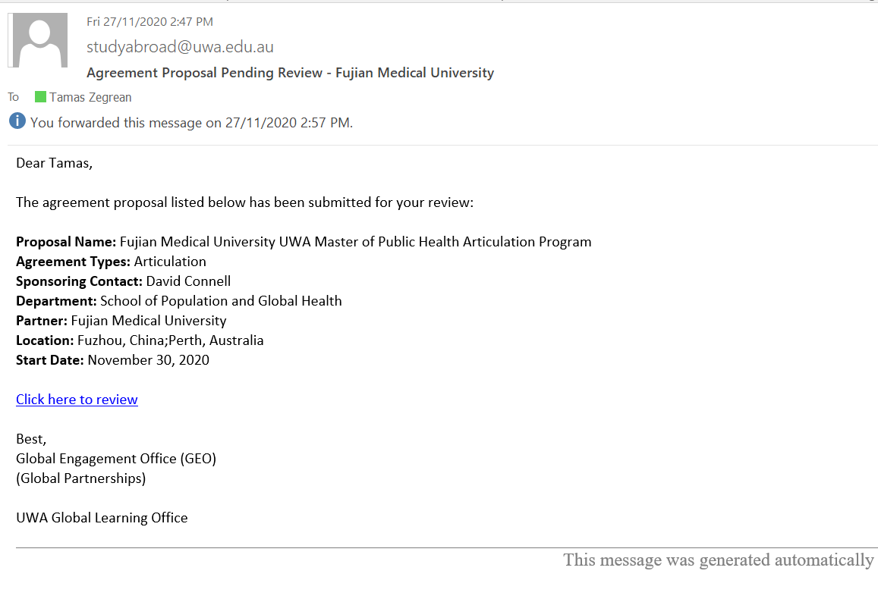

The Approver can click on the link from the email which will open a web browser without having to log into the online system. The Approver can review the proposal using the various tabs, download relevant attachments and then approve/reject via the green and red buttons. There is an optional comment section to record any comments. Note, any comments will be visible to all Approvers, Agreement Admin and the Sponsor (Proposer).
The agreement approval history tab can be used to check status of proposal and confirm who has already approved the proposal. This approval history is visible to both Agreement Admin and each Approver.

Screen shot below shows approval history and other available tabs:
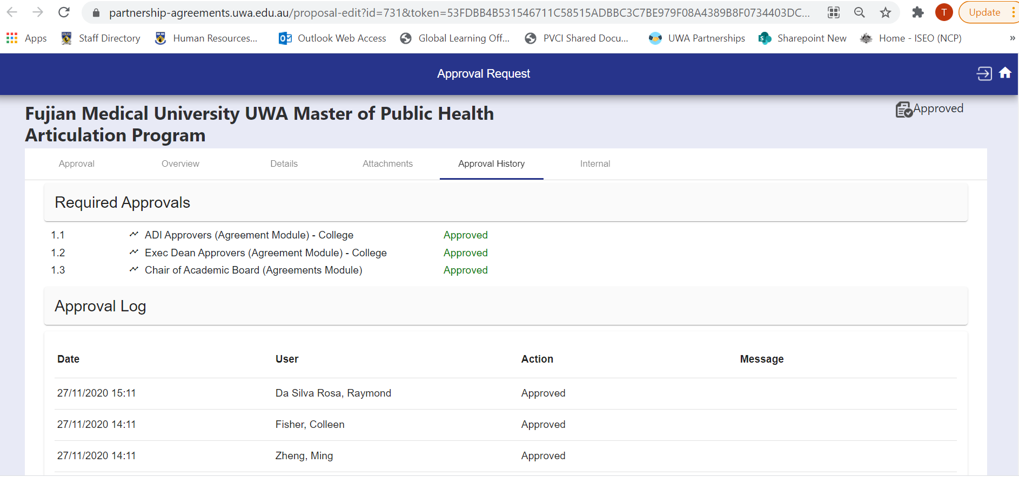

Example of approval request visible to Approvers:
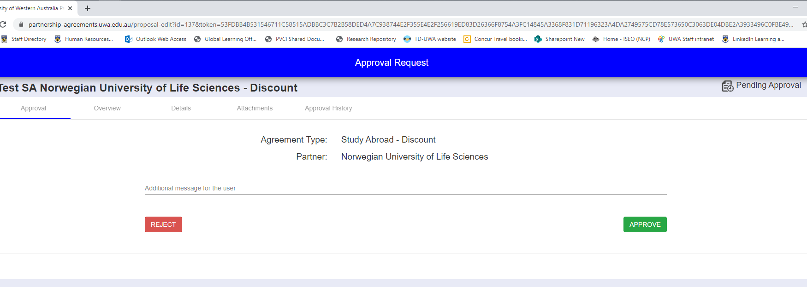

Once 1st Approver clicks the green “approve” button an auto generated email will be sent to the 2nd approver prompting them to do the same. If for any reason a proposal is rejected, an auto generated notification will be sent to the Agreement Admin (GEO) and the proposer (sponsor contact on the proposal). The rejected proposal can then be amended and re-submitted for approval from the beginning or discarded altogether.
The Agreement Admin receives automated notification each time an Approver responds (approve/reject). If a proposal has been idle for a long period of time, the Agreement Admin will receive notification to follow up.

Example of typical approval workflow:
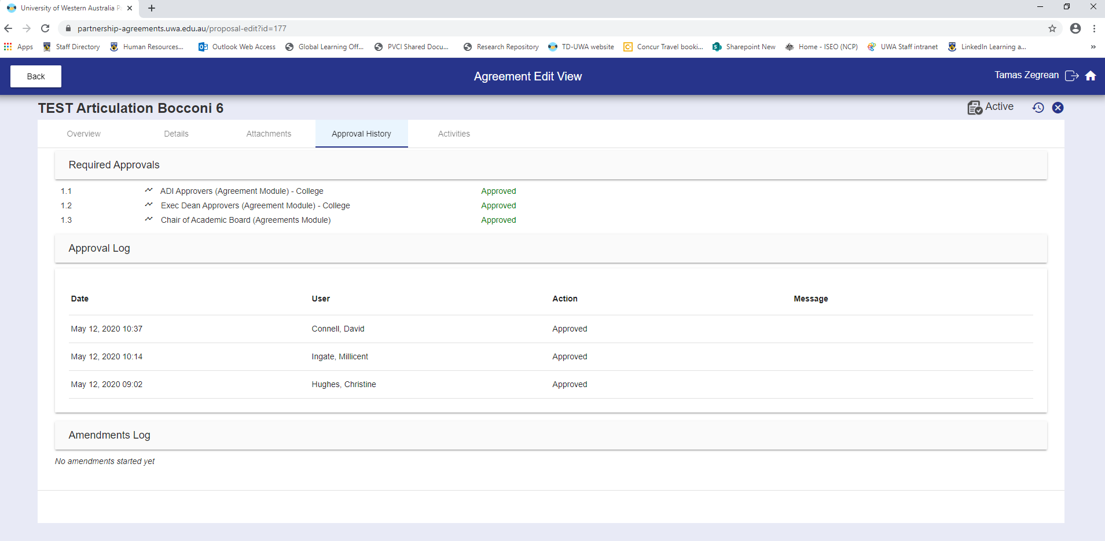
Note: when logged into the GEO-IPAD, Proposer can see status of the proposal they submitted.
Once approved by the last Approver an automated notification is sent to Agreement Admin to process the agreement.

Agreement renewals for existing partners
Similarly, for the renewal of existing agreements the Agreement Admin will submit a recommendation to renew the agreement to the relevant approver groups. A similar process with a revised workflow according to each agreement type will be routed accordingly and recorded in the approval history.

Example of Agreement Admin view to recommend/ not recommend renewal:
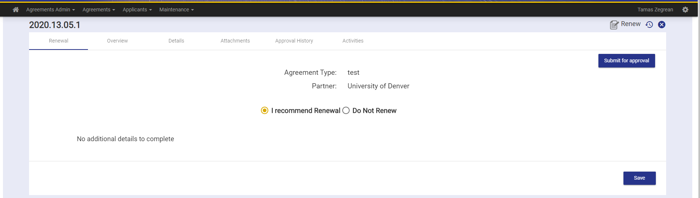

Example of approval workflow for a Student Exchange renewal:
